A Micro Project report on

Building Personal Portfolio Website

##### Submitted to the CMR Institute of Technology in partial fulfillment of the requirement for the award of the Laboratory of

**Full Stack Web Development**

**of**

**III-B. Tech II-Semester**

### In

### Computer Science and Engineering Department

##### Submitted by

A.NITISH REDDY 21R01A0502

A.PAVAN 21R01A0505

SOLOMON 21R01A0522

K.GNANAVARDHAN 21R01A0530

M.DHARMESH 21R01A0542

M.SANTOSH NAYAK 21R01A0543

T.NISCHAY REDDY 21R01A0558

Under the Guidance of

### Mr.G.Rajesham

Assistant Professor, Department of CSE



**CMR INSTITUTE OF TECHNOLOGY**

**(UGC AUTONOMOUS)**

**(Approved by AICTE, Affiliated to JNTU, Kukatpally, Hyderabad)**

**Kandlakoya, Medchal Road, Hyderabad**

**2023-2024**

**CMR INSTITUTE OF TECHNOLOGY**

**(UGC AUTONOMOUS)**

**(Approved by AICTE, Affiliated to JNTU, Kukatpally, Hyderabad) Kandlakoya, Medchal Road, Hyderabad.**

**Department of Computer Science and Engineering**



**CERTIFICATE**

##### This is to certify that a Micro Project entitled with: “Build a personal portfolio”

##### Submitted By

A.NITISH REDDY 21R01A0502

A.PAVAN 21R01A0505

SOLOMON 21R01A0522

K.GNANAVARDHAN 21R01A0530

M.DHARMESH 21R01A0542

M.SANTOSH NAYAK 21R01A0543

T.NISCHAY REDDY 21R01A0558

In partial fulfillment of the requirement for award of the Full Stack Web Development laboratory of III B. Tech II - Semester in CSE towards a record of a bonafide work carried out under our guidance and supervision.

**Signature of Faculty Signature of HOD**

### ACKNOWLEDGEMENT

We are extremely grateful to **Dr.M. Janga Reddy**, **Director**, **Dr. B. Satyanarayana**, **Principal** and **Prof. Mr. A. Prakash, Head of Department**, Department of Computer Science and Engineering, CMR Institute of Technology for their inspiration and valuable guidance during entire duration.

##### We are extremely thankful to our Full Stack Web Development Laboratory in-charge and Faculty Mr.G.Rajesham, Asst. Professor, Computer Science and Engineering department, CMR Institute of Technology for their constant guidance, encouragement and moral support throughout the project.

We express our thanks to all staff members and friends for all the help and coordination extended in bringing out this Project successfully in time.

##### Finally, we are very much thankful to our parents and relatives who guided directly or indirectly for the successful completion of the project.

##### Submitted by

A.NITISH REDDY 21R01A0502

A.PAVAN 21R01A0505

SOLOMON 21R01A0522

K.GNANAVARDHAN 21R01A0530

M.DHARMESH 21R01A0542

M.SANTOSH NAYAK 21R01A0543

T.NISCHAY REDDY 21R01A0558

**CONTENTS:**

|  |  |
| --- | --- |
| **TOPICS** | **PAGE.NO** |
| 1.Introduction | 5 |
| 2.Making a portfolio | 6-9 |
| 3.Benefits of portfolio | 10 |
| 4. Technologies Used | 11-13 |
| 5. Implementation | 14-22 |
| 6. Result | 23 |
| 7. Conclusion | 24 |
| 8. References | 25 |

# Introduction

A personal portfolio landing page is a website that showcase your work, skills, and experience in a professional manner. It’s a digital portfolio that allows potential clients or employees skills, and experience in a professional manner. It's a digital portfolio that allows potential clients or employers to learn more about you and your work. Personal portfolio landing pages typically include examples of your work, your professional background, and your contact information to others.

Personal portfolio landing pages are important because they can help you stand out in a crowded job market. They provide an opportunity to showcase your skills and experience in a way that is tailored to your personal brand. Having a personal portfolio landing page can also help you demonstrate your skills to potential clients or employers, even if you don't have a lot of work experience.

In addition, personal portfolio landing pages can be accessed from anywhere at any time, which means that potential clients or employers can view your work and contact information at their convenience. This makes it easier for them to learn more about you and potentially reach out for further discussion or opportunities.

As a student, you may not have enough commissioned work to put on a portfolio. Hence, your student portfolio may be indicative of your coursework, academic capabilities and achievements. You may include your academic credentials, like focus subjects, topics of interest, commendable assignment work and examination transcripts. If you have extracurricular work or explorations that you want to share, you can present them alongside your academic work in your student portfolio.

This documentation will guide you through the creation, customization, and deployment of your own personal portfolio website. You'll find detailed instructions, best practices, and tips to help you build a portfolio website that reflects your personality, showcases your work effectively, and leaves a lasting impression on your visitors. From setting up the project to deploying it live on the web, we'll cover every step of the process to ensure your portfolio website stands out from the crowd.

**Making Portfolio**

While deciding on how to make a portfolio, follow these steps to create one:

**Identify your best work samples :**

To create a portfolio, identify your best work samples and collate them creatively. Try to maintain diversity and keep the content engaging. The person who views your portfolio may only have limited time to go through the entirety of it, so consider planning your layout in such a way that you can communicate important pieces of information easily.

**Create a contents section :**

If your portfolio has many projects, it is important that you start it with a table or list of contents. This makes it easier for readers to navigate the content or sections that follow. Although you want to create this section after you have all your samples included in the order you want to display them, this is the first section that appears in your portfolio. Hence, it is required to catch the attention of the reader and motivate them to read further. If your document is large, then consider numbering your pages and including page numbers in the contents section.

**Include your resume :**

A resume complements your portfolio in most recruitment or interview situations. In your resume, you can provide basic contact information like your phone number, email address and location. You can also list your academic credentials like degrees, certifications and transcripts. If you have relevant work experience, including internships, mention them as well.

**Add a personal statement outlining your professional goals :**

Dedicate a section to outline your long-term and short-term professional goals. Short-term goals could be those that you are working on at the moment, which can be realized within a year or two. Long-term goals may include career plans spanning five to 10 years or more. Your personal statement and goals together can enable readers to assess your philosophy, worldview and work ethic.

**List out your hard skills and expertise :**

If you are preparing a portfolio for an interview or hiring situation, consider what skills the interviewer or potential employer might require. List those skills that complement the requirements of the position and go into detail to indicate the extent of your proficiency with each one. In addition to hard skills, you can also mention soft skills that may have helped you professionally.

**Attach samples of your best work :**

You want to make sure that your portfolio displays a comprehensive collection of your best work. Decide upon the layout and format of your portfolio with this in mind. For example, if you are a photographer, you can choose to make a physical portfolio with photographic prints or create a digital gallery of your best photographs. If you are an animator or a filmmaker, you may want to create an online platform where viewers can see your video work. You can also consider creating a single showreel every year, with snippets of your best work for that year.

**Include recommendations and testimonials from credible sources :**

Credible recommendations may come from your previous employers, supervisors or managers, coworkers, educators or mentors. If your workplace has employee evaluation programmes, you can also attach the latest assessment to your portfolio. You can request testimonials from customers or clients who are satisfied or happy with your product or service. Include professional credentials and contact information along with testimonials so that the reader can verify the information if required.

**Mention any awards or recognitions that you have received for your work :**

If there is documentation that is associated with an award or recognition, like a certificate, include it in your portfolio. If any of your recognitions have received media coverage, you can use clippings from newspapers or magazines to provide proof of your achievements. If you do not have supporting materials, you may simply list the honors you have received and provide contextual information, like the name of the issuing authority and the date.

**Provide references :**

If you have people who can vouch for your skills and talents and are interested in promoting them, you can add them as references to your portfolio. This may include your coworkers, superiors, mentors, previous clients or educators. List each reference and attach their information, including name, designation, email address, phone number and mailing address.

**Benefits Of Portfolio**

* **Showcasing your work :**

A personal portfolio landing page allows you to showcase your work in a way that highlights your skills and experience. You can display your best work, explain your creative process, and highlight your achievements.

* **Standing out in a crowded job market :**

In today's competitive job market, having a personal portfolio landing page can help you stand out from other candidates. It can demonstrate your skills and experience in a way that sets you apart from other applicants.

* **Demonstrating your skills :**

A personal portfolio landing page can demonstrate your skills to potential clients or employers, even if you don't have a lot of work experience. It can showcase your ability to create visually appealing designs, write compelling content, or develop complex applications.

* **Providing a central location for your work :**

A personal portfolio landing page provides a central location for your work, making it easy for potential clients or employers to access your work and contact information.

* **Improving your online presence :**

Having a personal portfolio landing page can help improve your online presence by showcasing your work and providing a professional image. This can be particularly helpful if you are freelancing or looking for new job opportunities.

**Technologies Used**

**HTML Code :**

To get started, we will first need to create a basic HTML file. In this file, we will include the main structure for our portfolio website.

After creating the files just paste the following below codes into your file. Make sure to save your HTML document with a .html extension, so that it can be properly viewed in a web browser. The code starts with the <!DOCTYPE html> declaration, which specifies the HTML version being used. This is followed by the html tag, which contains the rest of the document.

Inside the html tag, there is the head section, which includes metadata such as the page title, character encoding, and stylesheets. The meta tag defines the character encoding and the viewport, which adjusts the page layout to fit different device sizes. The link tags load external stylesheets, including Font Awesome and Owl Carousel, which provide icon fonts and a responsive carousel. The body section contains the page content, including the navigation bar (nav), several sections (section), and a scroll-to-top button (div).

Each section has a unique identifier (id) that can be used to link to that section from the navigation bar. The content of each section is defined by HTML tags such as h2, p, and a, which specify headings, paragraphs, and links, respectively. The sections also include classes (class) to apply CSS styles.

The script tags load external JavaScript, including Font Awesome icon library, jQuery JavaScript library, Typed.js library which provides typing animations, Waypoints library which allows you to trigger functions when an element in the page is scrolled to, and Owl Carousel library which provides a carousel slider. This is the basic structure of our portfolio website using HTML, and now we can move on to styling it using CSS.

**CSS Code :**

Once the basic HTML structure of the portfolio website is in place, the next step is to add styling to the portfolio website using CSS. CSS allows us to control the visual appearance of the website, including things like layout, color, and typography. Next, we will create our CSS file. In this file, we will use some basic CSS rules to create our portfolio website. The CSS code that defines the styling for a web page. Let's go through it section by section:

The first section sets default values for all elements on the page. It sets the margin and padding to 0, makes the box-sizing border-box, and removes text decoration.

The second section sets the scroll-behavior to smooth for the HTML element, which will enable smooth scrolling for the page.

The next few sections define the styles for the scroll bar on the page, including its width, background color, and appearance when hovered over. The .loader_bg and .loader classes define styles for a loading screen that covers the entire page. The .navbar class defines the styles for the navigation bar at the top of the page, including its position, z-index, padding, and font. It also defines the styles for the logo and menu items in the navbar.

The .menu-btn and .scroll-up-btn classes define styles for a menu button and a scroll-up button that appear on the page. The .home class defines styles for the homepage of the website, including the background image and font. The owl-dot.active style sets the width and border radius of active owl dots, while contact sets a radial gradient background for the contact section, and social-menu styles the appearance of social media icons in the footer.

The stylesheet also includes a media query, which adjusts the styling of certain elements when the screen size is below a certain width. This will give our portfolio website an upgraded presentation. Create a CSS file with the name of styles.css and paste the given codes into your CSS file. Remember that you must create a file with the .css extension.

**JavaScript Code :**

Finally, we need to create an interactivity function in JavaScript. The code is a JavaScript script that performs several functions on a webpage.

Firstly, it uses jQuery to detect when the page has finished loading and then listens for any scrolling activity on the page. When the user scrolls, it checks if the user has scrolled more than 20 pixels from the top of the page, and if so, it adds a "sticky" class to the navbar to keep it fixed at the top of the page. It also checks if the user has scrolled more than 500 pixels down the page, and if so, it adds a class to a scroll-up button to make it visible.

When the user clicks on the scroll-up button, it animates the page to smoothly scroll back to the top of the page. The script also toggles smooth scrolling behavior on and off depending on whether the user clicks on a menu item or the scroll-up button. The script also provides a typing animation effect using a JavaScript library called Typed.js. This effect displays a sequence of strings with a typing animation and loops through them continuously.

Finally, the script uses another JavaScript library called Owl Carousel to create a responsive image carousel that displays a set of images with a configurable number of items visible at different screen sizes.

Create a JavaScript file with the name of script.js and paste the given codes into your JavaScript file and make sure it's linked properly to your HTML document, so that the scripts are executed on the page. Remember, you’ve to create a file with .js extension.

**Implementation**

**HTML Code :**

<!DOCTYPE html>

<html lang="en">

<head>

<title>Portfolio Landing Page</title>

<meta charset="UTF-8" />

<meta name="viewport" content="width=device-width" />

<link rel='stylesheet' href='https://cdnjs.cloudflare.com/ajax/libs/font-awesome/5.15.3/css/all.min.css'>

<link rel='stylesheet' href='https://cdn.jsdelivr.net/npm/bootstrap-icons@1.8.2/font/bootstrap-icons.css'>

<link rel='stylesheet' href='https://fonts.googleapis.com/css2?family=Comfortaa:wght@300;400;500;600;700&family=Poppins:wght@100;300;400;500;600;700;800;900&family=Ubuntu:wght@300;400;500;700&display=swap"rel="stylesheet'>

<link rel='stylesheet' href='https://cdnjs.cloudflare.com/ajax/libs/OwlCarousel2/2.3.4/assets/owl.carousel.min.css'>

<link rel="stylesheet" href="styles.css" />

</head>

<body>

<div class="scroll-up-btn">

<i class="fas fa-angle-up"></i>

</div>

<!-- Header -->

<nav class="navbar">

<div class="max-width">

<div class="logo"><a href="#"><span>AISTECHX</span><span>.com</span></a></div>

<ul class="menu">

<li><a href="#home" class="menu-btn"><strong>Home</strong></a></li>

<li><a href="#about" class="menu-btn"><strong>About</strong></a></li>

<li><a href="#services" class="menu-btn"><strong>Services</strong></a></li>

<li><a href="#skills" class="menu-btn"><strong>Skills</strong></a></li>

<li><a href="#projects" class="menu-btn"><strong>Projects</strong></a></li>

<li><a href="#contact" class="menu-btn"><strong>Contact</strong></a></li>

</ul>

<div class="menu-btn">

<i class="fas fa-bars"></i>

</div>

</div>

</nav>

<!-- Home -->

<section class="home" id="home">

<div class="max-width">

<div class="home-content">

<div class="text-1">Hello, This is</div>

<div class="text-2">Akash Mahapatra</div>

<div class="text-3">And I'm a <span class="typing"></span></div>

<a href="#">Hire me</a>

</div>

</div>

</section>

<!-- About -->

<section class="about" id="about">

<div class="max-width">

<h2 class="title">About Me</h2>

<div class="about-content">

<div class="column left">

<img src="https://source.unsplash.com/626x626/?profile" alt="Profile Image 626x626">

</div>

<div class="column right">

<div class="text">I'm Akash and I'm a <span class="typing-2"></span></div>

<p>Seeking an entry-level opportunity with an esteemed organization where I can utilize my skills & enhance learning in the field of work. Capable of mastering new technologies.</p>

<br>

<div class="text">Why Work With Me</div>

<p>I'm a great communicator & love to invest the necessary time to understand the customer's problem very well.</p>

<a href="#link" target="blank">Download CV</a>

</div>

</div>

</div>

</section>

<!-- Services -->

<section class="services" id="services">

<div class="max-width">

<h2 class="title">My services</h2>

<div class="serv-content">

<div class="card">

<div class="box">

<i class="fas fa-laptop-code"></i>

<div class="text">Web Design</div>

<p>Your Next Web Developer, who is working in Shopify Dropshipping Stores, High Converting Ecommerce stores, Product Page also having Custom code, liquid template design.</p>

</div>

</div>

<div class="card">

<div class="box">

<i class="fas fa-user-secret"></i>

<div class="text">User Secret</div>

<p>I ensures that, there is no sensitive data included in the source code and are stored outside of the project folder. And all the data which is stored by User Secrets is not encrypted.</p>

</div>

</div>

<div class="card">

<div class="box">

<i class="fas fa-code"></i>

<div class="text">Apps Design</div>

<p>I encompasses both the user interface(UI) & user experience(UX). The overall style of the app, including things like the colour scheme, font selection, and the types of buttons and widgets which will use.</p>

</div>

</div>

</div>

</div>

</section>

<!-- Skills -->

<section class="skills" id="skills">

<div class="max-width">

<h2 class="title">My Skills</h2>

<div class="skills-content">

<div class="column left">

<div class="text">INTERNSHIP</div>

<p>

<li class="intern">#Company Name "Where You work"</li>

<li class="intern">#Company Name "Where You work"</li>

<li class="intern">#Company Name "Where You work"</li>

</p>

<br>

<div class="text">PROJECT</div>

<p>

<li class="project">Portfolio (HTML, CSS, js, Bootstraps)</li>

<li class="project">eCommerce Website (Shopify liquid-code, HTML, CSS)</li>

<li class="project">QuickShop - eCommerce Website (Like Amazon, Flipkart etc.)</li>

<li class="project">Fully Responsive Design Email Subscribe form</li>

<li class="project">Blog (HTML, CSS, Bootstraps)</li>

<li class="project">Currently Working on a Messaging App (Like WhatsApp)</li>

</p>

<br>

<div class="text">DEVELOPMENT SKILLS</div>

<p>

I'm familiar & work on a daily basis with HTML, CSS, JavaScript, Bootstrap, React js and other modern frameworks.

</p>

<a href="#" target="blank">Get Educate...</a>

</div>

<div class="column right">

<div class="bars">

<div class="info">

<span>Python</span>

<span>90%</span>

</div>

<div class="line python"></div>

</div>

<div class="bars">

<div class="info">

<span>HTML</span>

<span>80%</span>

</div>

<div class="line html"></div>

</div>

<div class="bars">

<div class="info">

<span>CSS</span>

<span>60%</span>

</div>

<div class="line css"></div>

</div>

<div class="bars">

<div class="info">

<span>JavaScript</span>

<span>40%</span>

</div>

<div class="line js"></div>

</div>

<div class="bars">

<div class="info">

<span>Bootstraps</span>

<span>60%</span>

</div>

<div class="line bootstraps"></div>

</div>

<div class="bars">

<div class="info">

<span>Django</span>

<span>70%</span>

</div>

<div class="line django"></div>

</div>

</div>

</div>

</div>

</section>

<!-- Projects -->

<section class="projects" id="projects">

<div class="max-width">

<h2 class="title">My Projects</h2>

<div class="carousel owl-carousel">

<div class="card">

<div class="box">

<img src="https://source.unsplash.com/720x600/?shopping" alt="">

<div class="text">Ecommerce</div>

<p>#Project Details:- Lorem ipsum dolor sit amet consectetur adipisicing elit.</p>

</div>

</div>

<div class="card">

<div class="box">

<img src="https://source.unsplash.com/720x600/?portfolio" alt="">

<div class="text">Portfolio</div>

<p>#Project Details:- Lorem ipsum dolor sit amet consectetur adipisicing elit.</p>

</div>

</div>

<div class="card">

<div class="box">

<img src="https://source.unsplash.com/720x600/?blog" alt="">

<div class="text">Blog</div>

<p>#Project Details:- Lorem ipsum dolor sit amet consectetur adipisicing elit.</p>

</div>

</div>

<div class="card">

<div class="box">

<img src="https://source.unsplash.com/720x600/?messanger" alt="">

<div class="text">Messaging App</div>

<p>#Project Details:- Lorem ipsum dolor sit amet consectetur adipisicing elit.</p>

</div>

</div>

<div class="card">

<div class="box">

<img src="https://source.unsplash.com/720x600/?app-clone" alt="">

<div class="text">Clone</div>

<p>#Project Details:- Lorem ipsum dolor sit amet consectetur adipisicing elit.</p>

</div>

</div>

<div class="card">

<div class="box">

<img src="https://source.unsplash.com/720x600/?code,demo" alt="">

<div class="text">Demo</div>

<p>#Project Details:- Lorem ipsum dolor sit amet consectetur adipisicing elit.</p>

</div>

</div>

</div>

</div>

</section>

<!-- Contact -->

<section class="contact" id="contact">

<div class="max-width">

<h2 class="title">Contact Me</h2>

<div class="contact-content">

<div class="column left">

<div class="text">Get in Touch</div>

<p>Feel free to get in touch with me. I am always open to discussing new projects, creative ideas or opportunities to be a part of your visions. Email me with any questions or inquiries. I'll happy to answer your questions and set up a meeting with you.</p>

<div class="icons">

<a href="#">

<div class="row">

<i class="fa-solid fa-user-large"></i>

<div class="info">

<div class="head">Name</div>

<div class="sub-title"><a href="#" style="text-decoration: none; color: #333;"> Akash Mahapatra</a></div>

</div>

</div>

</a>

<div class="row">

<i class="fa-solid fa-location-dot"></i>

<div class="info">

<div class="head"> Address</div>

<div class="sub-title"> ABC, 123 Lane, India</div>

</div>

</div>

<div class="row">

<i class="fa-solid fa-envelope"></i>

<div class="info">

<div class="head">Email</div>

<div class="sub-title"><a href="mailto:#" style="text-decoration: none; color: #333;"> example@example.com</a></div>

</div>

</div>

<div class="row">

<i class="bi bi-translate"></i>

<div class="info">

<div class="head">Language Known</div>

<div class="sub-title">Hindi, English, Odia, Bengali</div>

</div>

</div>

<br>

<!-- Social -->

<div class="social-menu">

<ul>

<li><a href="#"><i class="fa-brands fa-github"></i></a></li>

<li><a href="#"><i class="fa-brands fa-linkedin-in"></i></a></li>

<li><a href="#"><i class="fa-brands fa-instagram"></i></a></li>

<li><a href="#"><i class="fa-brands fa-twitter"></i></a></li>

<li><a href="#" title="Get Educate with Us"><i class="fa-solid fa-graduation-cap"></i></a></li>

</ul>

</div>

</div>

</div>

<!-- Reach -->

<div class="column right">

<div class="text">Message me</div>

<form action="#">

<div class="fields">

<div class="field name">

<input type="text" placeholder="Your Name" required>

</div>

<div class="field email">

<input type="email" placeholder="Your Email" required>

</div>

</div>

<div class="field">

<input type="text" placeholder="Subject" required>

</div>

<div class="field textarea">

<textarea cols="30" rows="10" placeholder="Message.." required></textarea>

</div>

<div class="button-area">

<button type="submit">Send message</button>

</div>

</form>

</div>

</div>

</div>

</section>

<!-- Footer -->

<footer>

<span>

<a href="#"> Akash Mahapatra</a> | <span class="far fa-copyright"></span> 2022 All Rights Reserved. Privacy Policy

</span>

</footer>

<script src='https://kit.fontawesome.com/3b57a2a2a7.js'></script>

<script src='https://code.jquery.com/jquery-3.5.1.min.js'></script>

<script src='https://cdnjs.cloudflare.com/ajax/libs/typed.js/2.0.11/typed.min.js'></script>

<script src='https://cdnjs.cloudflare.com/ajax/libs/waypoints/4.0.1/jquery.waypoints.min.js'></script>

<script src='https://cdnjs.cloudflare.com/ajax/libs/OwlCarousel2/2.3.4/owl.carousel.min.js'></script>

<script src="script.js"></script>

</body>

</html>

**CSS Code :**

* {

margin: 0;

padding: 0;

box-sizing: border-box;

text-decoration: none;

}

html {

scroll-behavior: smooth;

}

::-webkit-scrollbar {

width: 6px;

}

::-webkit-scrollbar-track {

background: #f1f1f1;

}

.loader_bg {

position: fixed;

z-index: 9999999;

background: #fff;

width: 100%;

height: 100%;

}

.loader {

height: 100%;

width: 100%;

position: absolute;

left: 0;

top: 0;

display: flex;

justify-content: center;

align-items: center;

}

.loader img {

width: 280px;

}

::-webkit-scrollbar-thumb {

border-radius: 12px;

background: linear-gradient(135deg, #f57308, #fff, rgb(11, 242, 7));

}

::-webkit-scrollbar-thumb:hover {

background: linear-gradient(135deg, #1a6ad2, #fff, rgb(245, 5, 53));

}

/* Simillar */

section {

padding: 100px 0;

}

.max-width {

max-width: 1300px;

padding: 0 80px;

margin: auto;

}

.about,

.services,

.skills,

.projects,

.contact,

footer {

font-family: "Poppins", sans-serif;

}

.about .about-content,

.services .serv-content,

.skills .skills-content,

.contact .contact-content {

display: flex;

flex-wrap: wrap;

align-items: center;

justify-content: space-between;

}

section .title {

position: relative;

text-align: center;

font-size: 40px;

font-weight: 500;

margin-bottom: 60px;

padding-bottom: 20px;

font-family: "Ubuntu", sans-serif;

}

section .title::before {

content: "";

position: absolute;

bottom: 0px;

left: 50%;

width: 180px;

height: 3px;

transform: translateX(-50%);

}

section .title::after {

position: absolute;

bottom: -8px;

left: 50%;

font-size: 20px;

color: #1e3551;

padding: 0 5px;

transform: translateX(-50%);

}

/* Navbar */

.navbar {

position: fixed;

width: 100%;

z-index: 999;

padding: 30px 0;

font-family: "Ubuntu", sans-serif;

transition: all 0.3s ease;

}

.navbar.sticky {

padding: 15px 0;

background: #1e3551;

}

.navbar .max-width {

display: flex;

align-items: center;

justify-content: space-between;

}

.navbar .logo a {

color: #fff;

font-size: 35px;

font-weight: 600;

}

/* Nav Logo Span Linear-Gradient */

.navbar .logo a span {

background: linear-gradient(135deg, #041d3d, #fff, crimson);

-webkit-background-clip: text;

-webkit-text-fill-color: transparent;

transition: all 0.3s ease;

}

.navbar.sticky .logo a span {

color: #fff;

}

.navbar .menu li {

list-style: none;

display: inline-block;

}

.navbar .menu li a {

display: block;

color: #fff;

font-size: 18px;

font-weight: 500;

margin-left: 25px;

transition: color 0.3s ease;

}

.navbar .menu li a:hover {

color: #1e3551;

}

.navbar.sticky .menu li a:hover {

color: #fff;

}

/* Menu Btn */

.menu-btn {

color: #fff;

font-size: 23px;

cursor: pointer;

display: none;

}

.scroll-up-btn {

position: fixed;

height: 45px;

width: 42px;

background: #1e3551;

right: 30px;

bottom: 10px;

text-align: center;

line-height: 45px;

color: #fff;

z-index: 9999;

font-size: 30px;

border-radius: 6px;

border-bottom-width: 2px;

cursor: pointer;

opacity: 0;

pointer-events: none;

transition: all 0.3s ease;

}

.scroll-up-btn.show {

bottom: 30px;

opacity: 1;

pointer-events: auto;

}

.scroll-up-btn:hover {

filter: brightness(90%);

}

/* Home */

.home {

display: flex;

background: url("https://source.unsplash.com/720x600/?dark,laptop") no-repeat

center;

height: 100vh;

color: #fff;

min-height: 500px;

background-size: cover;

background-attachment: fixed;

font-family: "Ubuntu", sans-serif;

}

.home .max-width {

width: 100%;

display: flex;

}

.home .max-width .row {

margin-right: 0;

}

.home .home-content .text-1 {

font-size: 27px;

}

.home .home-content .text-2 {

font-size: 75px;

font-weight: 600;

margin-left: -3px;

}

.home .home-content .text-3 {

font-size: 40px;

margin: 5px 0;

}

/* Linear Gradient */

.home .home-content .text-3 span {

color: #1e3551;

background: linear-gradient(135deg, #041d3d, #fff, crimson);

-webkit-background-clip: text;

-webkit-text-fill-color: transparent;

font-weight: 500;

}

.home .home-content a {

display: inline-block;

background: #1e3551;

color: #fff;

font-size: 25px;

padding: 12px 36px;

margin-top: 20px;

font-weight: 400;

border-radius: 6px;

border: 2px solid #1e3551;

transition: all 0.3s ease;

}

.home .home-content a:hover {

color: #1e3551;

background: none;

animation: pulsate 1s ease-in-out;

}

/* About */

.about {

background: radial-gradient(#e1efff, white);

}

.about .title::after {

content: "—Who I Am ?—";

text-overflow: ellipsis;

display: -webkit-inline-box;

-webkit-line-clamp: 3;

-webkit-box-orient: vertical;

}

.about .about-content .left {

width: 45%;

}

.about .about-content .left img {

height: 400px;

width: 400px;

object-fit: cover;

border-radius: 6px;

}

.about .about-content .right {

width: 55%;

}

.about .about-content .right .text {

font-size: 25px;

font-weight: 600;

margin-bottom: 10px;

}

/* Linear Gradiant */

.about .about-content .right .text span {

/* color: #1e3551; */

background: linear-gradient(135deg, #041d3d, #fff, crimson);

-webkit-background-clip: text;

-webkit-text-fill-color: transparent;

}

.about .about-content .right p {

text-align: justify;

}

.about .about-content .right a {

display: inline-block;

background: #1e3551;

color: #fff;

font-size: 20px;

font-weight: 500;

padding: 10px 30px;

margin-top: 20px;

border-radius: 6px;

border: 2px solid #1e3551;

transition: all 0.3s ease;

}

.about .about-content .right a:hover {

color: #1e3551;

background: none;

animation: pulsate 1s ease-in-out;

}

/* Service */

.services,

.projects {

color: #fff;

background: #111;

}

.services .title::before,

.projects .title::before {

background: #fff;

}

.services .title::after,

.projects .title::after {

background: #111;

content: "What I Provide ?";

}

.services .serv-content .card {

width: calc(33% - 20px);

background: #222;

text-align: center;

border-radius: 10px;

padding: 50px 25px;

cursor: pointer;

transition: all 0.3s ease;

}

.services .serv-content .card:hover {

background: #1e3551;

}

.services .serv-content .card .box {

transition: all 0.3s ease;

}

.services .serv-content .card:hover .box {

transform: scale(1.05);

}

.services .serv-content .card i {

font-size: 50px;

color: #888e8d;

background: linear-gradient(135deg, #041d3d, #fff, crimson);

-webkit-background-clip: text;

-webkit-text-fill-color: transparent;

transition: color 0.3s ease;

}

.services .serv-content .card:hover i {

color: #fff;

}

.services .serv-content .card .text {

font-size: 25px;

font-weight: 500;

margin: 10px 0 7px 0;

}

/* Skills */

.skills {

background: radial-gradient(#e1efff, white);

}

.skills .title::after {

content: "—What I Know ?—";

}

.skills .skills-content .column {

width: calc(50% - 30px);

}

.skills .skills-content .left .text {

font-size: 20px;

font-weight: 600;

margin-bottom: 10px;

}

.skills .skills-content .left p {

text-align: justify;

}

.skills .skills-content .left a {

display: inline-block;

background: #1e3551;

color: #fff;

font-size: 18px;

font-weight: 500;

padding: 8px 16px;

margin-top: 20px;

border-radius: 6px;

border: 2px solid #1e3551;

transition: all 0.3s ease;

}

.skills .skills-content .left a:hover {

color: #1e3551;

background: none;

animation: pulsate 1s ease-in-out;

}

.intern,

.project {

list-style: none;

}

.intern::before,

.project::before {

content: "✪ ";

color: #1e3551;

}

.skills .skills-content .right .bars {

margin-bottom: 15px;

}

.skills .skills-content .right .info {

display: flex;

margin-bottom: 5px;

align-items: center;

justify-content: space-between;

}

.skills .skills-content .right span {

font-weight: 500;

font-size: 18px;

}

.skills .skills-content .right .line {

height: 5px;

width: 100%;

background: lightgrey;

position: relative;

}

.skills .skills-content .right .line::before {

content: "";

position: absolute;

height: 100%;

left: 0;

top: 0;

background: #1e3551;

}

.skills-content .right .python::before {

width: 90%;

}

.skills-content .right .html::before {

width: 80%;

}

.skills-content .right .css::before {

width: 60%;

}

.skills-content .right .js::before {

width: 40%;

}

.skills-content .right .bootstraps::before {

width: 60%;

}

.skills-content .right .django::before {

width: 70%;

}

/* Projects */

.projects .title::after {

content: "What I did ?";

}

.projects .carousel .card {

background: #222;

border-radius: 6px;

padding: 25px 35px;

text-align: center;

overflow: hidden;

transition: all 0.3s ease;

}

.projects .carousel .card:hover {

background: #1e3551;

}

.projects .carousel .card .box {

display: flex;

flex-direction: column;

align-items: center;

justify-content: center;

transition: all 0.3s ease;

}

.projects .carousel .card:hover .box {

transform: scale(1.05);

}

.projects .carousel .card .text {

font-size: 25px;

font-weight: 500;

margin: 10px 0 7px 0;

}

.projects .carousel .card img {

height: 150px;

width: 150px;

object-fit: cover;

border-radius: 50%;

border: 5px solid #888c8d;

transition: all 0.3s ease;

}

.projects .carousel .card:hover img {

border-color: #fff;

}

.owl-dots {

text-align: center;

margin-top: 20px;

}

.owl-dot {

height: 13px;

width: 13px;

margin: 0 5px;

outline: none !important;

border-radius: 50%;

border: 2px solid #888c8d !important;

transition: all 0.3s ease;

}

.owl-dot.active {

width: 35px;

border-radius: 14px;

}

.owl-dot.active,

.owl-dot:hover {

background: #18365a !important;

}

/* Contact */

.contact {

background: radial-gradient(#e1efff, white);

}

.contact .title::after {

content: "—Get in Touch—";

}

.contact .contact-content .column {

width: calc(50% - 30px);

}

.contact .contact-content .text {

font-size: 20px;

font-weight: 600;

margin-bottom: 10px;

}

.contact .contact-content .left p {

text-align: justify;

}

.contact .contact-content .left .icons {

margin: 10px 0;

}

.contact .contact-content .row {

display: flex;

height: 65px;

align-items: center;

}

.contact .contact-content .row .info {

margin-left: 30px;

}

.contact .contact-content .row i {

font-size: 25px;

color: #1e3551;

}

.contact .contact-content .info .head {

font-weight: 500;

color: #000;

}

.contact .contact-content .info .sub-title {

color: #333;

}

.contact .right form .fields {

display: flex;

}

.contact .right form .field,

.contact .right form .fields .field {

height: 45px;

width: 100%;

margin-bottom: 15px;

}

.contact .right form .textarea {

height: 80px;

width: 100%;

}

.contact .right form .name {

margin-right: 10px;

}

.contact .right form .field input,

.contact .right form .textarea textarea {

height: 100%;

width: 100%;

border: 1px solid lightgrey;

border-radius: 6px;

outline: none;

padding: 0 15px;

font-size: 17px;

font-family: "Poppins", sans-serif;

transition: all 0.3s ease;

}

.contact .right form .field input:focus,

.contact .right form .textarea textarea:focus {

border-color: #b3b3b3;

}

.contact .right form .textarea textarea {

padding-top: 10px;

resize: none;

}

.contact .right form .button-area {

display: flex;

align-items: center;

}

.right form .button-area button {

color: #fff;

display: block;

width: 160px !important;

height: 45px;

outline: none;

font-size: 18px;

font-weight: 500;

border-radius: 6px;

cursor: pointer;

flex-wrap: nowrap;

background: #1e3551;

border: 2px solid #1e3551;

transition: all 0.3s ease;

}

.right form .button-area button:hover {

color: #1e3551;

background: none;

animation: pulsate 1s ease-in-out;

}

/* Social */

.col-4 {

background: #d8d8d8;

}

.social-menu ul {

position: absolute;

left: 20%;

padding: 0;

margin: 0;

transform: translate(-50%, -50%);

display: flex;

}

.social-menu ul li {

list-style: none;

margin: 0 15px;

}

.social-menu ul li .fa {

font-size: 30px;

line-height: 60px;

transition: 0.6s;

color: #000;

}

.social-menu ul li .fa:hover {

color: #fff;

}

.social-menu ul li a {

left: px;

right: 12px;

padding-top: 3px;

position: relative;

display: block;

width: 30px;

height: 30px;

border-radius: 50%;

background-color: #1e3551;

text-align: center;

transition: 0.6s;

box-shadow: 0 5px 4px rgba(0, 0, 0, 0.5);

}

.social-menu ul li a:hover {

transform: translate(0, -10px);

}

.social-menu ul li:nth-child(1) a:hover {

background-color: #131418;

}

.social-menu ul li:nth-child(2) a:hover {

background-color: #0a66c2;

}

.social-menu ul li:nth-child(3) a:hover {

background-color: #e4405f;

}

.social-menu ul li:nth-child(4) a:hover {

background-color: #1da1f2;

}

.social-menu ul li:nth-child(5) a:hover {

background-color: #e33054;

}

.social-menu ul li:nth-child(6) a:hover {

background-color: #fc4f08;

}

.fa-brands {

color: #fff;

}

.fa-solid {

color: #fff;

}

/* Footer */

footer {

background: #111;

padding: 6px 16px;

color: #888c8d;

text-align: center;

}

footer span a {

color: #1e3551;

text-decoration: none;

}

footer span a:hover {

text-decoration: underline;

}

/* Media Query */

@keyframes pulsate {

0% {

box-shadow: 0 0 25px #888e8d, 0 0 50px #1e3551;

}

}

@media (max-width: 1104px) {

.about .about-content .left img {

height: 350px;

width: 350px;

}

section .title::after {

bottom: -8px;

font-size: 16px;

}

}

@media (max-width: 991px) {

.social-menu ul li a {

left: 114px;

}

}

@media (max-width: 947px) {

.menu-btn {

display: block;

z-index: 999;

}

.menu-btn i.active:before {

content: "\f00d";

}

.navbar .menu {

position: fixed;

height: 100vh;

width: 100%;

left: -100%;

top: 0;

background: #111;

text-align: center;

padding-top: 80px;

transition: all 0.3s ease;

}

.navbar .menu.active {

left: 0;

}

.navbar .menu li {

display: block;

}

.navbar .menu li a {

display: inline-block;

margin: 20px 0;

font-size: 25px;

}

.home .home-content .text-2 {

font-size: 70px;

}

.home .home-content .text-3 {

font-size: 35px;

}

.home .home-content a {

font-size: 23px;

padding: 10px 30px;

}

.max-width {

max-width: 930px;

}

.about .about-content .column {

width: 100%;

}

.about .about-content .left {

display: flex;

justify-content: center;

margin: 0 auto 60px;

}

.about .about-content .right {

flex: 100%;

}

.services .serv-content .card {

width: calc(50% - 10px);

margin-bottom: 20px;

}

.skills .skills-content .column,

.contact .contact-content .column {

width: 100%;

margin-bottom: 35px;

}

}

@media (max-width: 690px) {

.max-width {

padding: 0 23px;

}

.home .home-content .text-2 {

font-size: 60px;

}

.home .home-content .text-3 {

font-size: 32px;

}

.home .home-content a {

font-size: 20px;

}

.services .serv-content .card {

width: 100%;

}

}

@media (max-width: 500px) {

.home .home-content .text-2 {

font-size: 50px;

}

.home .home-content .text-3 {

font-size: 27px;

}

.about .about-content .right .text,

.skills .skills-content .left .text {

font-size: 19px;

}

.contact .right form .fields {

flex-direction: column;

}

.contact .right form .name,

.contact .right form .email {

margin: 0;

}

.right form .error-box {

width: 150px;

}

.scroll-up-btn {

right: 15px;

bottom: 15px;

height: 38px;

width: 35px;

font-size: 23px;

line-height: 38px;

}

}

**JavaScript Code :**

$(document).ready(function () {

$(window).scroll(function () {

// sticky navbar on scroll script //

if (this.scrollY > 20) {

$(".navbar").addClass("sticky");

} else {

$(".navbar").removeClass("sticky");

}

// scroll-up button show/hide script //

if (this.scrollY > 500) {

$(".scroll-up-btn").addClass("show");

} else {

$(".scroll-up-btn").removeClass("show");

}

});

// slide-up script //

$(".scroll-up-btn").click(function () {

$("html").animate({ scrollTop: 0 });

// removing smooth scroll on slide-up button click //

$("html").css("scrollBehavior", "auto");

});

$(".navbar .menu li a").click(function () {

// Smooth scroll on Menu Items click //

$("html").css("scrollBehavior", "smooth");

});

// Toggle Navbar //

$(".menu-btn").click(function () {

$(".navbar .menu").toggleClass("active");

$(".menu-btn i").toggleClass("active");

});

// Typing Text Animation //

var typed = new Typed(".typing", {

strings: [

"Fullstack Developer",

"Software Developer",

"Python Developer",

"Founder",

"Author"

],

typeSpeed: 100,

backSpeed: 60,

loop: true

});

var typed = new Typed(".typing-2", {

strings: [

"Fullstack Developer",

"Software Developer",

"Python Developer",

"Founder",

"Author"

],

typeSpeed: 100,

backSpeed: 60,

loop: true

});

// Owl Carousel //

$(".carousel").owlCarousel({

margin: 20,

loop: true,

autoplay: true,

autoplayTimeOut: 2000,

autoplayHoverPause: true,

responsive: {

0: {

items: 1,

nav: false

},

600: {

items: 2,

nav: false

},

1000: {

items: 3,

nav: false

}

}

});

});

Result



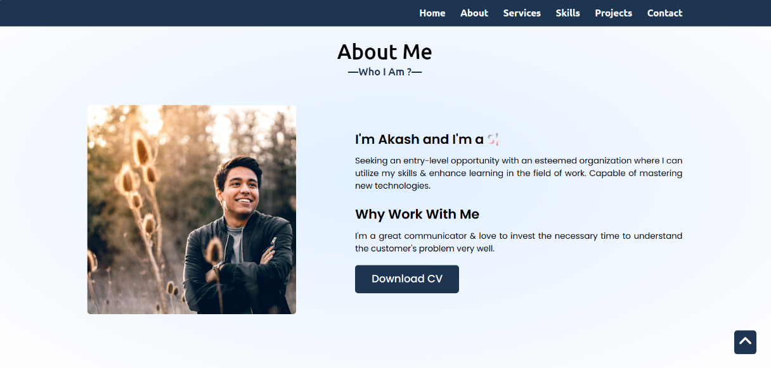

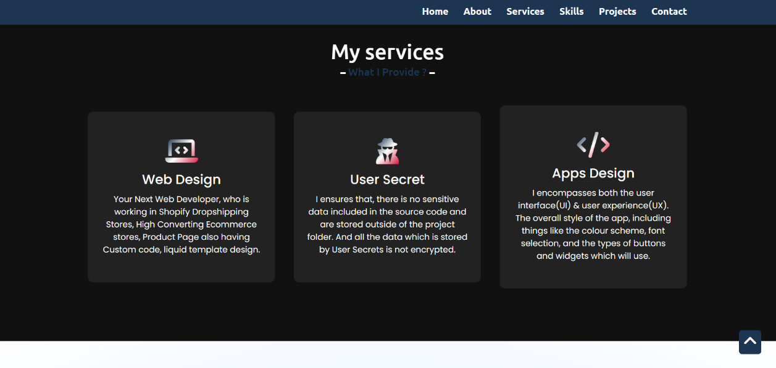

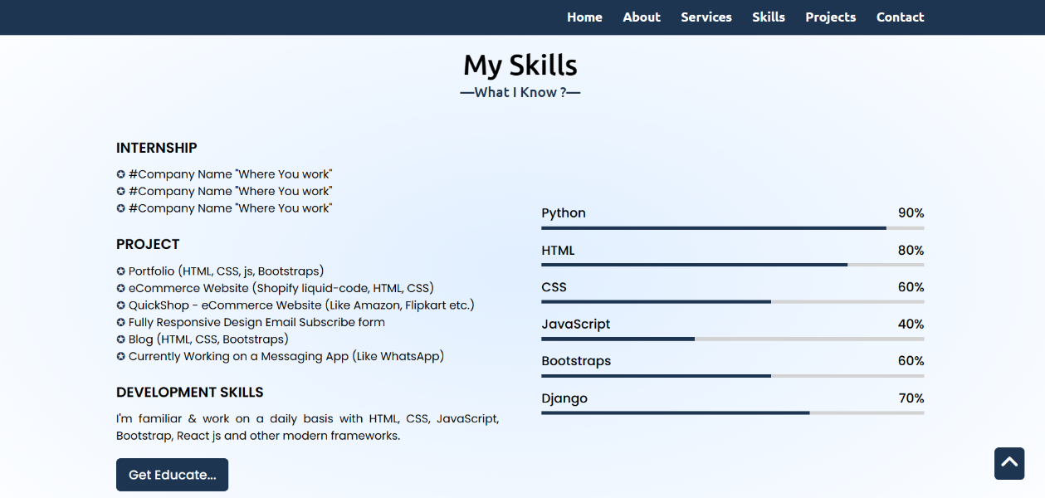

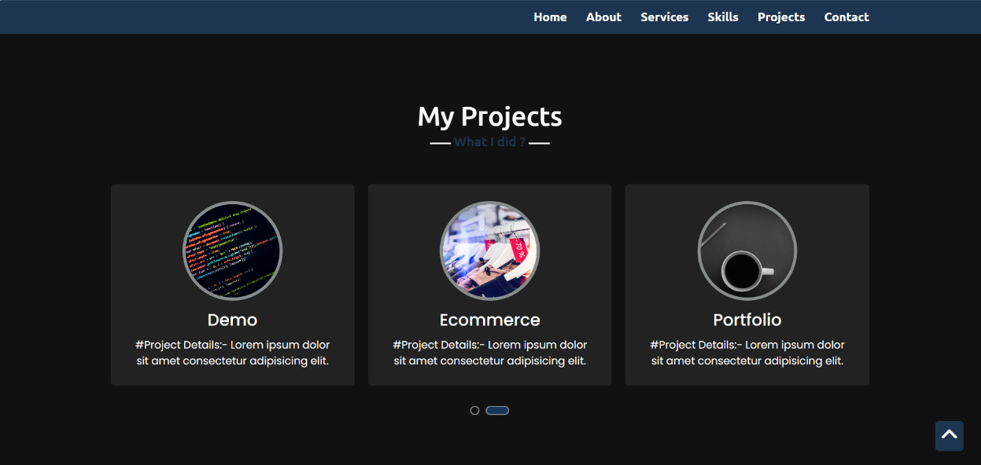

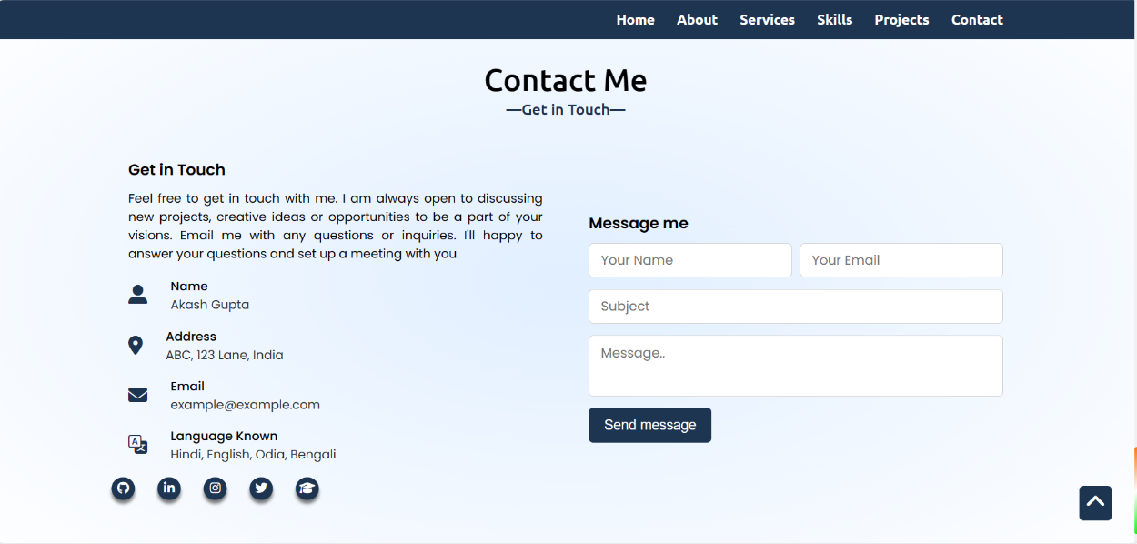

**Conclusion**

In conclusion to create a personal portfolio landing page using HTML, CSS, and JavaScript. We started by choosing a design and layout that reflects your personal brand, and then moved on to creating the HTML structure and styling the website with CSS. We also covered how to add interactivity with JavaScript and how to test and launch your website.

Creating a personal portfolio landing page is a great way to showcase your work, skills, and experience to potential clients or employers. It's a digital resume that can be accessed from anywhere at any time, and it can help you stand out in a crowded job market. By following the steps outlined in this guide, you can create a professional-looking website that showcases your work in the best possible light.

There are always ways to improve your personal portfolio landing page and make it even more effective. Consider adding new projects or updating your existing work to keep your website fresh and relevant. You can also explore new design trends and technologies to keep your website up-to-date. The key to success is to showcase your work in a clear and concise manner that reflects your personal brand

# References

* [Personal Portfolio Website: A Step-by-Step Guide with HTML, CSS, and JavaScript (codewithfaraz.com)](https://www.codewithfaraz.com/content/139/personal-portfolio-website-a-step-by-step-guide-with-html-css-and-javascript#google_vignette)
* [Personal Portfolio using HTML, CSS & JS - CodeWithCurious](https://codewithcurious.com/projects/personal-portfolio-using-html-css-js/)
* [How To Make A Portfolio: A Step-By-Step Guide | Indeed.com India](https://in.indeed.com/career-advice/career-development/how-to-make-portfolio)
* [What is a PDF Portfolio? 10 Portfolio PDF Examples to Inspire Your Own (authory.com)](https://authory.com/blog/portfolio-pdf-examples)
* [HTML: HyperText Markup Language | MDN (mozilla.org)](https://developer.mozilla.org/en-US/docs/Web/HTML)
* [CSS: Cascading Style Sheets | MDN (mozilla.org)](https://developer.mozilla.org/en-US/docs/Web/CSS)